Stepping Up Your Crowdfunding Campaign With InventureX
Raising money in crowdfunding is something that a lot of businesses have tried in the last few years. Some people have had success, while others have come up short.
To increase the chances of success, many people have relied on InventureX. This is a company that helps with the marketing aspect of everything. They have helped a lot of entrepreneurs reach the goals, and they know what it takes to ensure that they put the idea in front of the right eyeballs.

Why is crowdfunding so popular these days?
Whenever something has success, more and more people try their hand at it. That is one of the major reasons why crowdfunding is so popular in 2019. Everyone is online these days, and it is one of the best ways to pick up financial support for a new project.
Crowdfunding has actually been around for years and proven works by entrepreneurs, but posting projects online make it that much easier. Even though it seems like a passive way to make income, there is still a lot of work that needs to be done. That is where InventureX's level of expertise can help out.
https://www.youtube.com/watch?v=ptTAGkQv8BQ

Staying ahead of the competition.
Since so many people know about the ability to raise money online, competition is very tough. InventureX helps give any person an advantage. Trying to get a campaign noticed without any type of assistance can be a huge uphill battle for many.
They know not only how to get the word out, but who to reach out to. If the right people see a certain project, there is a much higher chance of reaching funding goals. They tighten the entire selling package up so that the chances of success are as high as possible.
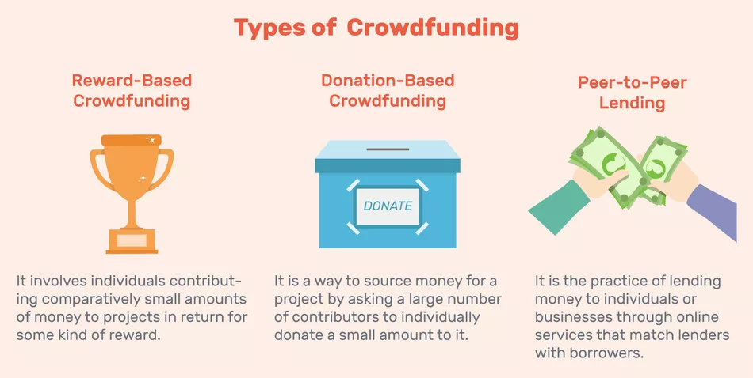

Is InventureX different than the competition?
While InventureX certainly is not the only company to help out with crowdfunding marketing, they do things a bit better than the rest. For starters, their focus is always on maximizing the chance of reaching funding goals. They relentlessly help with marketing so that the right people have a chance to invest.
They also provide some of the best customer support throughout the entire process. There are constant updates, and they can make adjustments on the fly if a certain process is not working. It's nice to see so many different options explored when trying to reach goals.

How easy is it to get started?
A lot of people who are interested in crowdfunding, in general, find it really easy to connect with InventureX. To get started, it all begins with filling out a simple application form on their website.
In a short amount of time, a customer service representative will reach out to gather more information. They will put together an initial offer plan, and then a person can work from there.

For those people who don't have much time, this is the fastest way to put together an effective crowdfunding campaign. Don't be afraid to take some extra time to figure it all out.

